Here are screenshots of 20 TD (tower defence) games, pointing out the elements of their HUD (heads up display). There is a variety the production value of the games as well as device they are played on

They generally share some common elements. They are:
Score – Used to keep track of how well the player is doing at the game. This may be used to compare with other players.
Lives Left – If this reaches zero, the player loses and the game is over.
Building Resources – Consumed to build new towers or upgrade existing towers. May be consumed for abilities as well.
Available Towers – Shows what towers could be built. May also show the cost of the towers.
Wave Information – Displays different information about the current and possibly next wave like the wave counter and what creeps (enemies your towers are trying to stop) the wave consists of.
Abilities – These are actions taken directly by the player that directly impact the creeps in some way like damaging or stunning them for a short period of time. May use its own specific resource or shares the same resources as for building towers.
Speed Settings – These setting pause the game or make the game faster so the player can have a bit more time to handle the current situation or speed things up if the player is bored.
Settings – These are options that generally don’t impact how the game is played but do impact what the player experiences. Examples of different options are the level of detail displayed, the volume and whether to restart the map.

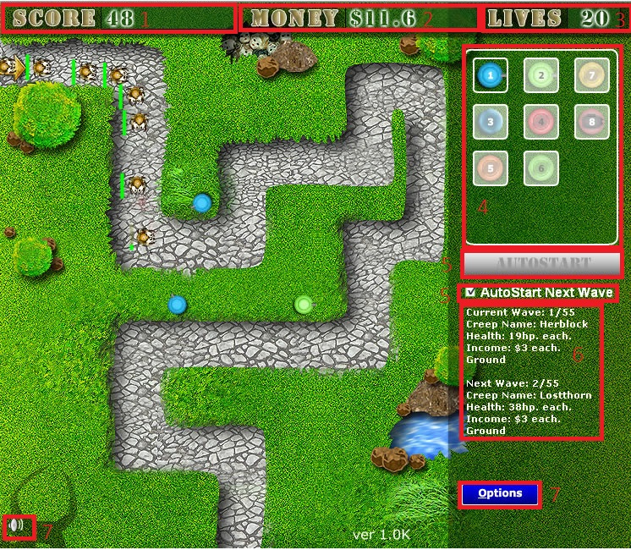
1. Tower Defence War
Played on computer.
Screenshot from http://www.qgames.org/game/tower-defence-war.html

Elements
1 - Current Score
2 - Current Building Resources
3 - Current Lives Left
4 - Available Towers
5 - Next Wave Control
6 - Current Wave and Next Wave Information
7 - Settings

2. Military Tower Defense
Played on smartphone and Nintendo Switch.
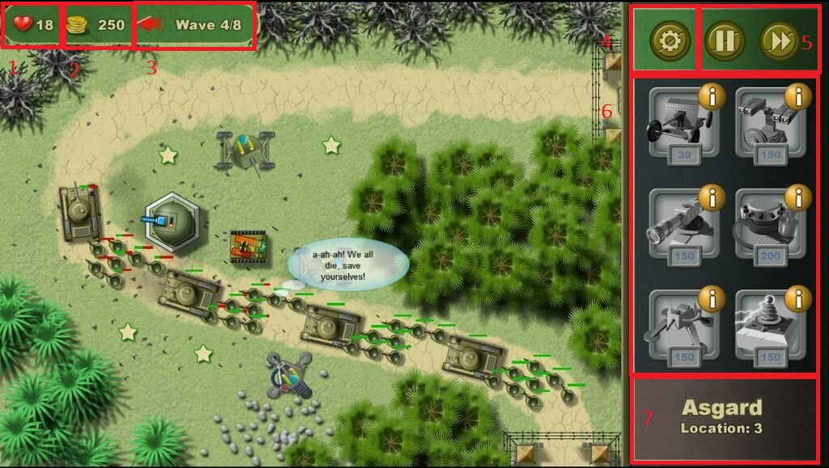

Screenshot from: https://www.moregameslike.com/military-tower-defense/

Elements
1 - Current Lives Left
2 - Current Building Resources
3 - Current Wave Information
4 - Settings
5 - Speed Settings
6 - Available Towers with Tower Cost
7 - Current Map Name

3. Tower Defense
Played on computer.
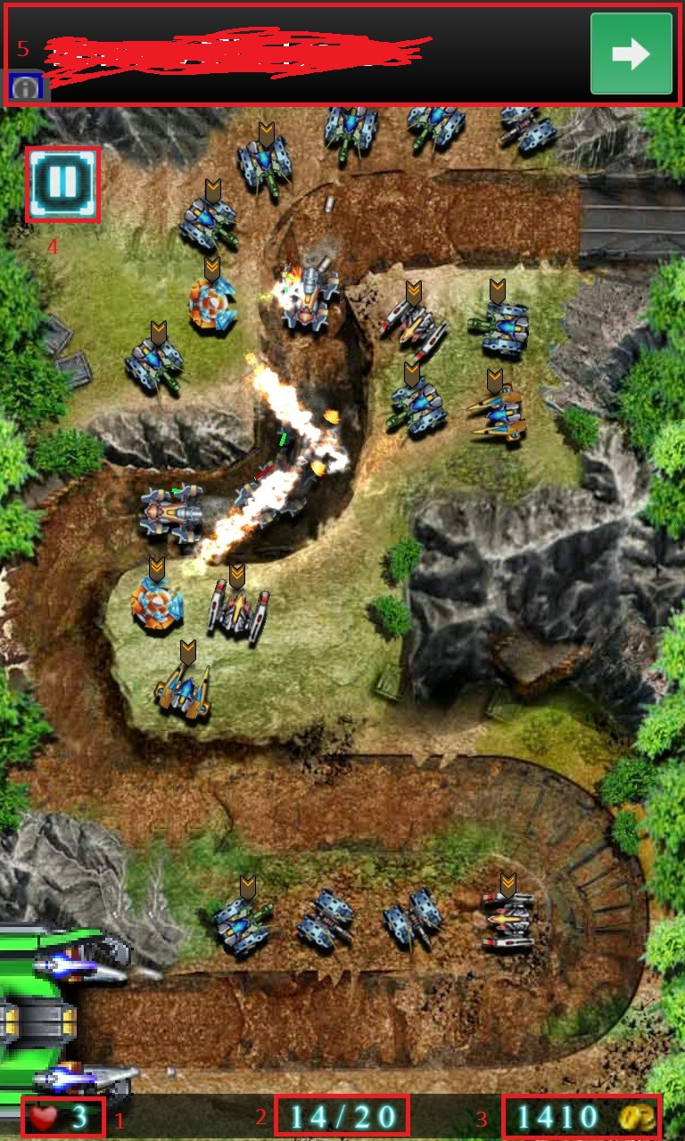

Screenshot from http://app4smart.com/en/wp/4629-tower-defense.html

Elements
1 - Current Lives Left
2 - Current Wave Information
3 - Current Building Resources
4 - Settings
5 – Advertising

4. Tower Defense King
Played on smartphone.
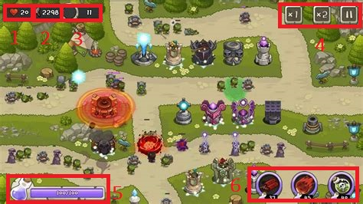

Screenshot from https://apkpure.com/tower-defense-king/com.mobirix.towerking

Elements
1 - Current Lives Left
2 - Current Building Resources
3 - Current Wave Information
4 - Speed Settings and Settings
5 - Current Ability Resources
6 - Ability List With Ability Cost

5. Defense Technica
Played on computer and Xbox 360.
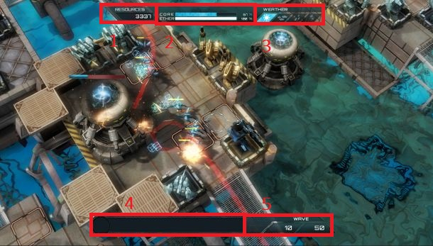

Screenshot from https://www.pcgamer.com/defense-technica-announced-a-tower-defence-game-that-looks-a-lot-like-a-tower-defence-game/

Elements
1 - Current Building Resources
2 - Current Lives Left at Top, Current Ability Resources at Bottom
3 - Current Map Status
4 - Current Wave Progress
5 - Current Wave Counter

Note – one thing that makes this game different from most other TD games is that the map has a status which impacts which tiles could have towers and which path the creeps could take.

6. Tower Defense Infinite War
Played on smartphone.
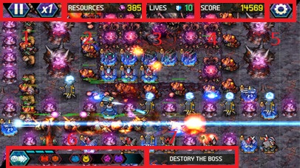
Screenshot from https://towerdefencegames.org/tower-defense-infinite-war/

Elements
1 - Speed Settings
2 - Current Building Resrouces
3 - Current Lives Left
4 - Current Score
5 - Settings
6 - Wave Information
7 – Objective

7. Fieldrunners
Played on smartphone.
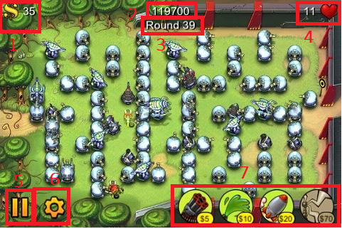

Screenshot from http://www.digitallydownloaded.net/2011/03/what-makes-good-tower-defence-game.html

Elements
1 - Current Building Resources
2 - Current Score
3 - Current Wave Information
4 - Current Lives Left
5 - Speed Settings
6 - Settings
7 - Available Towers

8. Dungeon Defenders
Played on computer, smartphone, Xbox 360 and PS3.
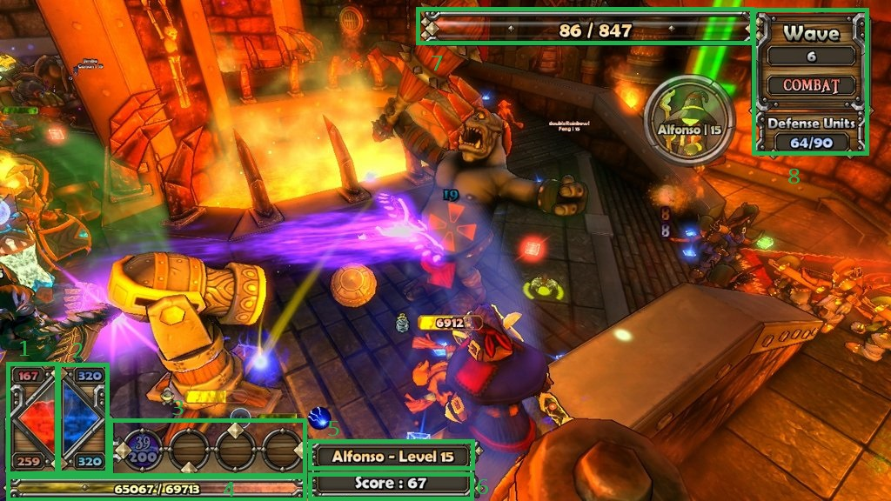
Screenshot from https://www.pushsquare.com/games/ps3/dungeon_defenders
Green was use for the markings as red features quite prominently in the image and won’t contrast with more red.

Elements
1 - Current Character Hit Points
2 - Current Building Resources
3 - Available Towers or Abilities List
4 - Current Character Experience
5 - Current Character Name
6 - Current Score
7 - Current Target Hit Points
8 - Current Wave Information

Note – Unlike most other TD games, the player controls a character which could be used to build structures including walls or directly attack a creep. Lives Left is not displayed as the character has to go the creep destination in order to see it’s remaining Lives.

9. Elemental Tower Defense
Played in Warcraft 3 on computer.

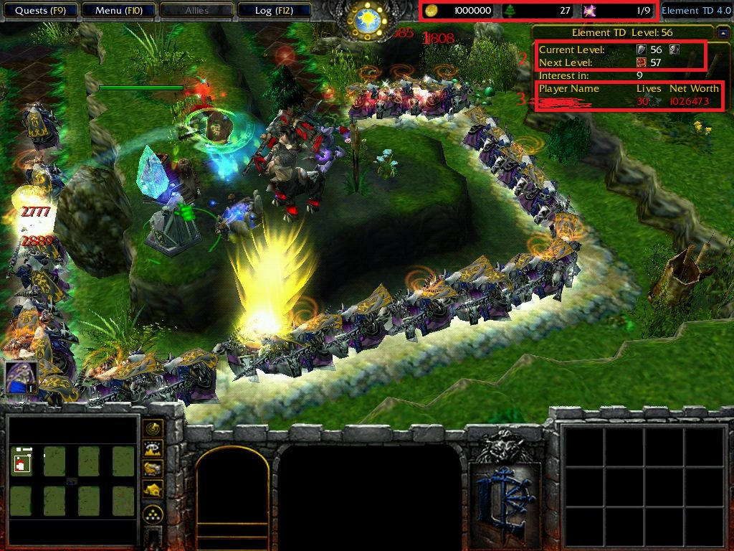
Screenshot from https://www.moddb.com/mods/element-tower-defense/images/in-game-screenshots

Elements
1 - Current Building Resources
2 - Current Wave Information
3 - Current Player Information

Note – This is a custom map for Warcraft 3, a RTS(real time strategy) game so this is not a stand alone game and many of the elements shown on screen were not used specifically for TD purposes. In terms of custom maps for Warcraft 3, this is actually quite a simple TD map as there are variations including co-op multiplayer TD maps, TD maps that include a controllable character and Tower Wars which involve players sending in creeps to their opponents’ areas while fending off creeps sent by their opponents.

10. Tower Defense 2D
Played on computer.
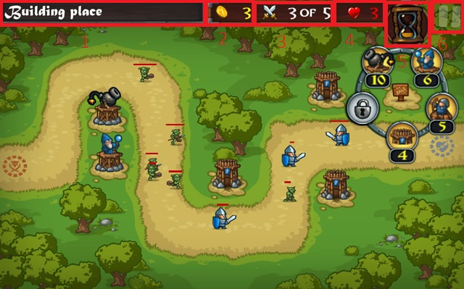
Screenshot from http://www.qgames.org/game/tower-defense-2d.html

Elements
1 - Current Map Name
2 - Current Building Resources
3 - Current Wave Information
4 - Current Lives Left
5 - Current Wave Progress
6 – Settings

11. Bloons Tower Defense 5
Played on computer and smartphone.
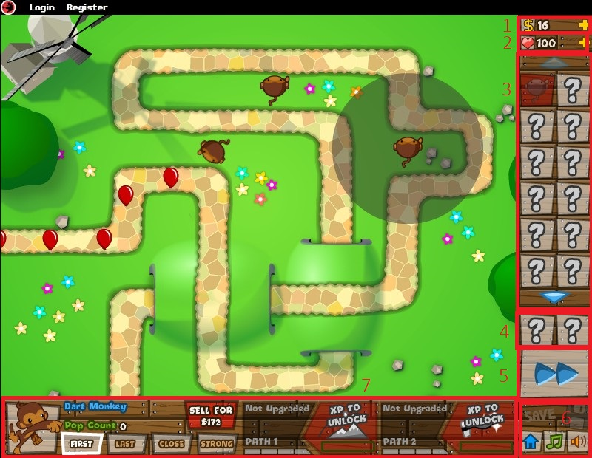

Screenshot from https://dewblacknoldames.blogspot.com/2015/09/bloons-tower-defense-5-all-upgrades.html

Elements
1 - Current Building Resources
2 - Current Lives Left
3 - Available Towers
4 - Abilities List
5 - Speed Settings
6 - Settings
7 - Selected Tower Information and Settings

12. Thing TD
Played on smartphone.

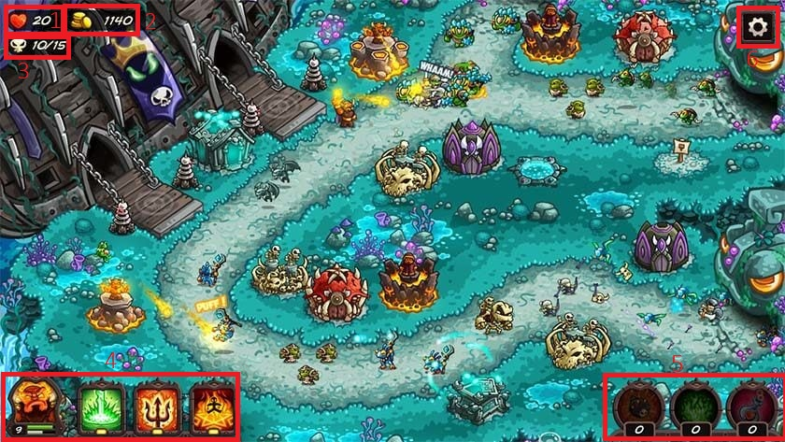
Screenshot from https://www.androidauthority.com/best-android-tower-defense-games-542624/

Elements
1 - Current Lives Left
2 - Current Building Resources
3 - Current Wave Information
4 - Current Character Information and Abilities
5 - Consumable Abilities
6 - Settings

13. Desktop Tower Defense
Played on computer and smartphone.
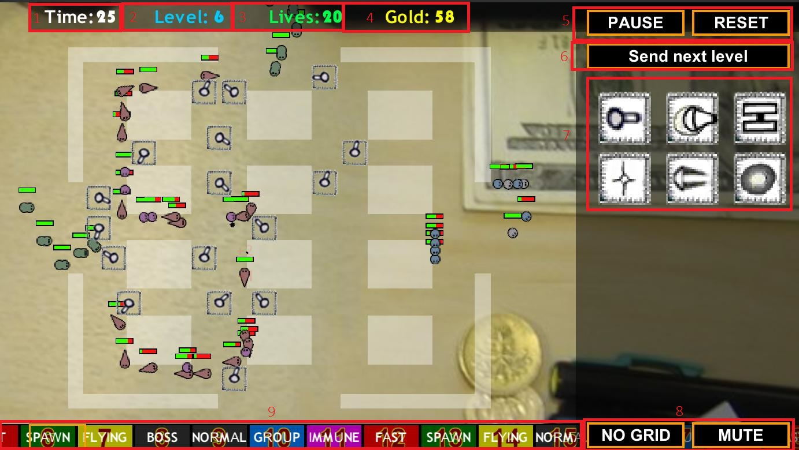
Screenshot from https://apkpure.com/desktop-tower-defense/com.YaudaGames.DTD

Elements
1 - Time Before Next Wave
2 - Current Wave Count
3 - Current Lives Left
4 - Current Building Resources
5 - Speed Settings
6 - Rush Next Wave Button
7 - Available Towers
8 - Settings
9 - Current Wave Progress

14. Iron Brigade
Played on computer, Xbox 360 and Xbox One.

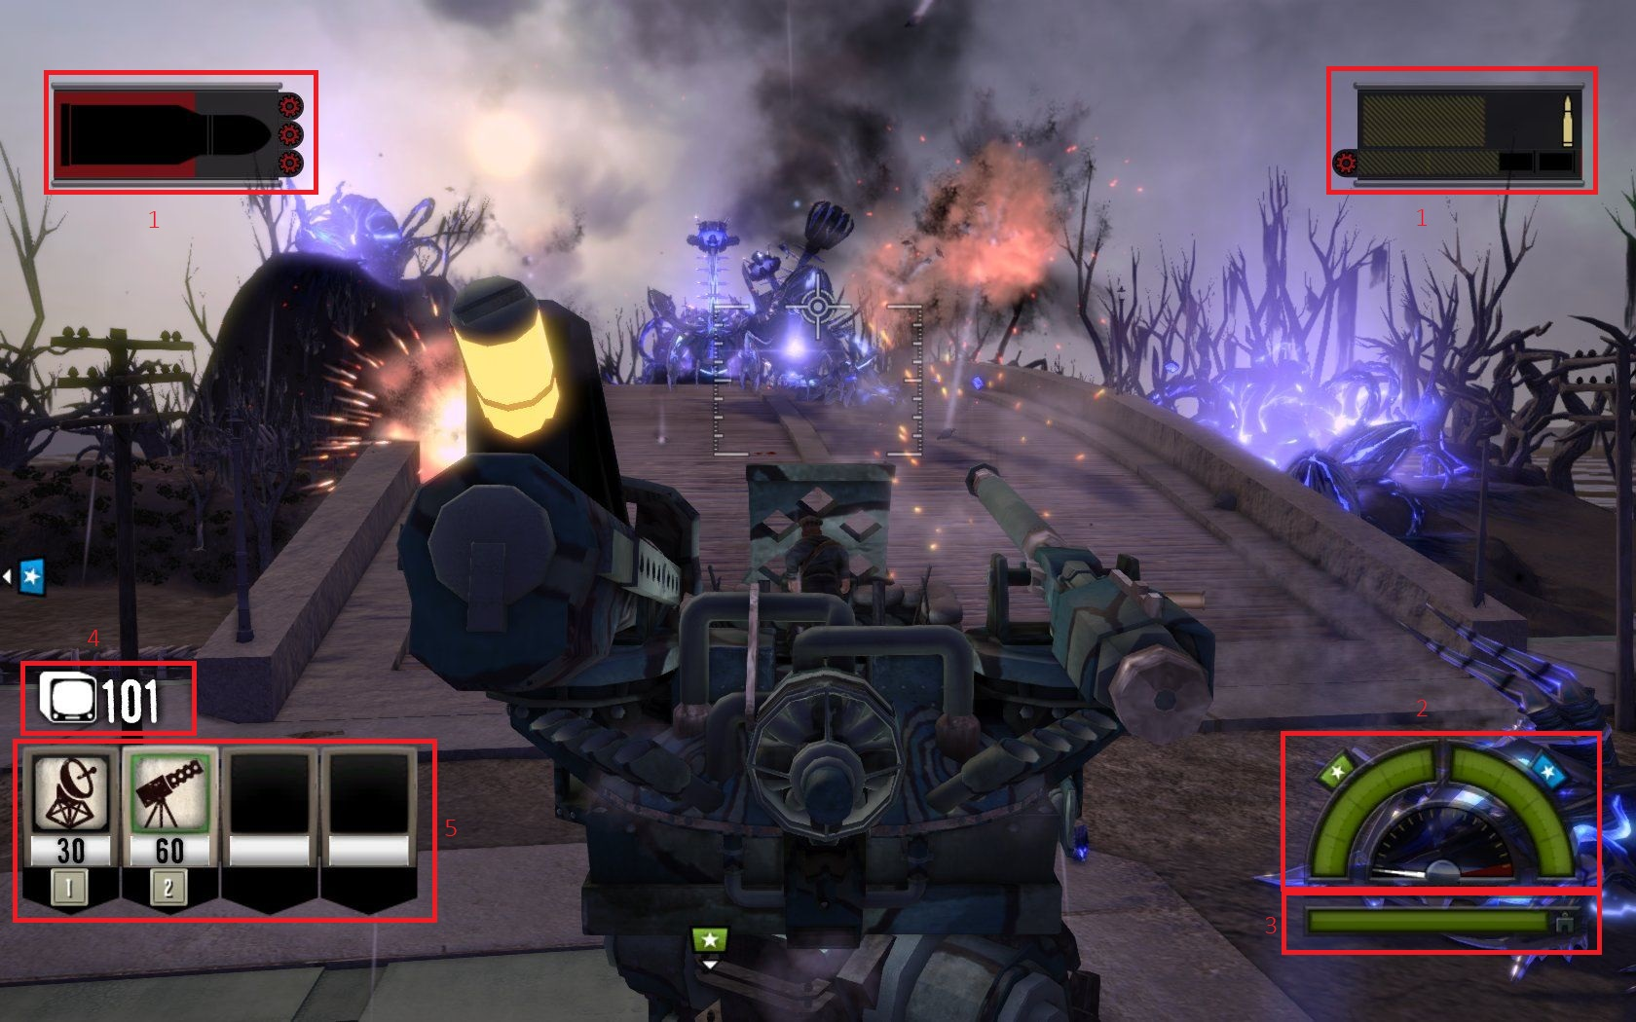
Screenshot from https://www.gamewatcher.com/games/iron-brigade/screens/33581

Elements
1 - Current Weapon Ammo
2 - Current Base Life Left
3 - Current Character Hit Points Left
4 - Current Building Resources
5 - Available Towers

Note – Like Dungeon Defenders, the player controls a character that can attack creeps and build towers on the map.

15. Inifinitode 2
Played on computer and smartphone.
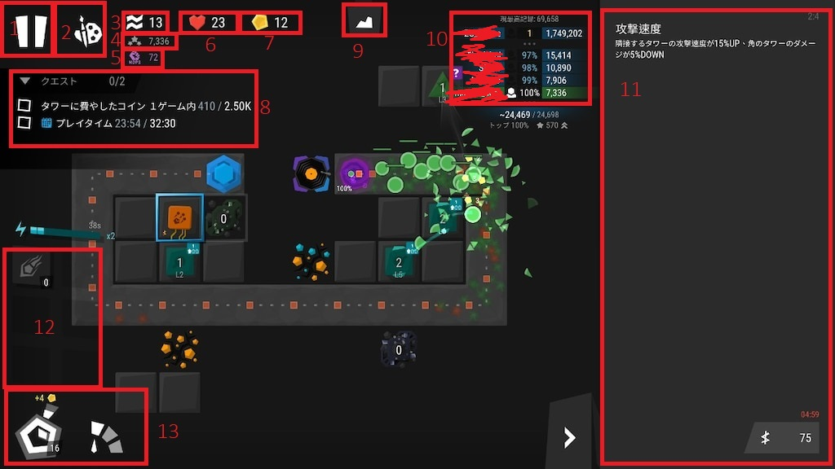
Screenshot from https://steamuserimages-a.akamaihd.net/ugc/1767079802781807383/F1B9B75A68C5F75065D72747C6ABFFA659D4502D/?imw=1024&&ima=fit&impolicy=Letterbox&imcolor=%23000000&letterbox=false

Elements
1 - Settings
2 - Toggle Tower Display
3 - Current Wave Count
4 - Damage Done Total
5 - Damage Per Second Average
6 - Current Lives Left
7 - Current Building Resources
8 - Objectives List
9 - Toggle In Depth Game Statistics
10 - Player Ranking for Map
11 - Available Towers and Selected Tower Information
12 - Consumable Abilities
13 - Speed Settings

16. Kingdom Rush
Played on computer and smartphone.

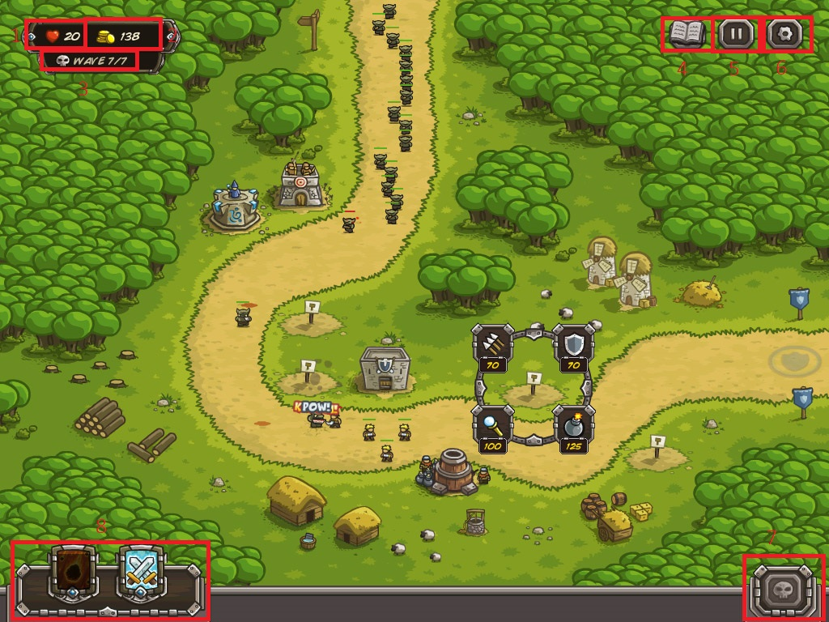
Screenshot from https://www.kingdomrush.com/home.html

Elements
1 - Current Lives Left
2 - Current Building Resources
3 - Current Wave Count
4 - Information on all Towers and Enemies
5 - Speed Settings
6 - Settings
7 - Rush Next Wave
8 - Abilities List

17. Final Fantasy Crystal Defenders
Played on smartphone, tablet, Xbox 360, PS3, PSP and Nintendo Wii.

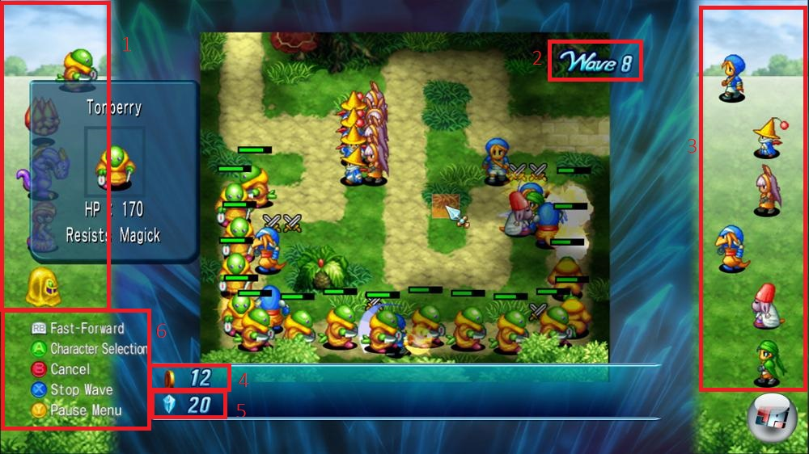
Screenshot from https://i0.wp.com/static.fore.4pcdn.de/premium/Screenshots/9f/4d/1921713-vollbild.jpg

Elements
1 - Current and Next Wave Information
2 - Current Wave Count
3 - Available Towers and Tower Recommendation for Current Wave
4 - Building Resources
5 - Ability Resources
6 - Control Information

18. Plants vs. Zombies
Played on computer, smartphone, Xbox 360, Xbox One, PS3, PS4, Playstation Vita, Nintendo Switch and Nintendo DS.

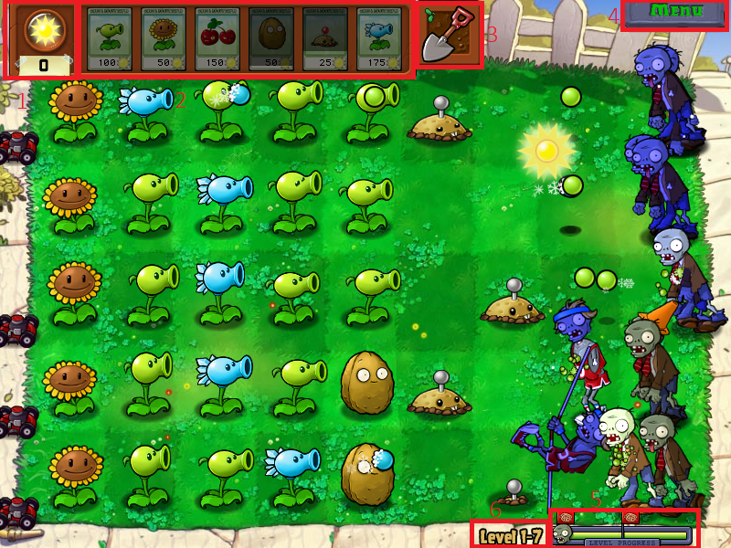
Screenshot from https://www.mobygames.com/game/windows/plants-vs-zombies/screenshots/gameShotId,368056/

Elements
1 - Current Building Resources
2 - Available Towers
3 - Option to Destroy Towers
4 - Settings
5 - Current Wave Progress
6 - Current Map Name

Note – There is no Lives Left element as the game is over when a single creep makes it to their destination.

19. Castle Defense
Played on smartphone.

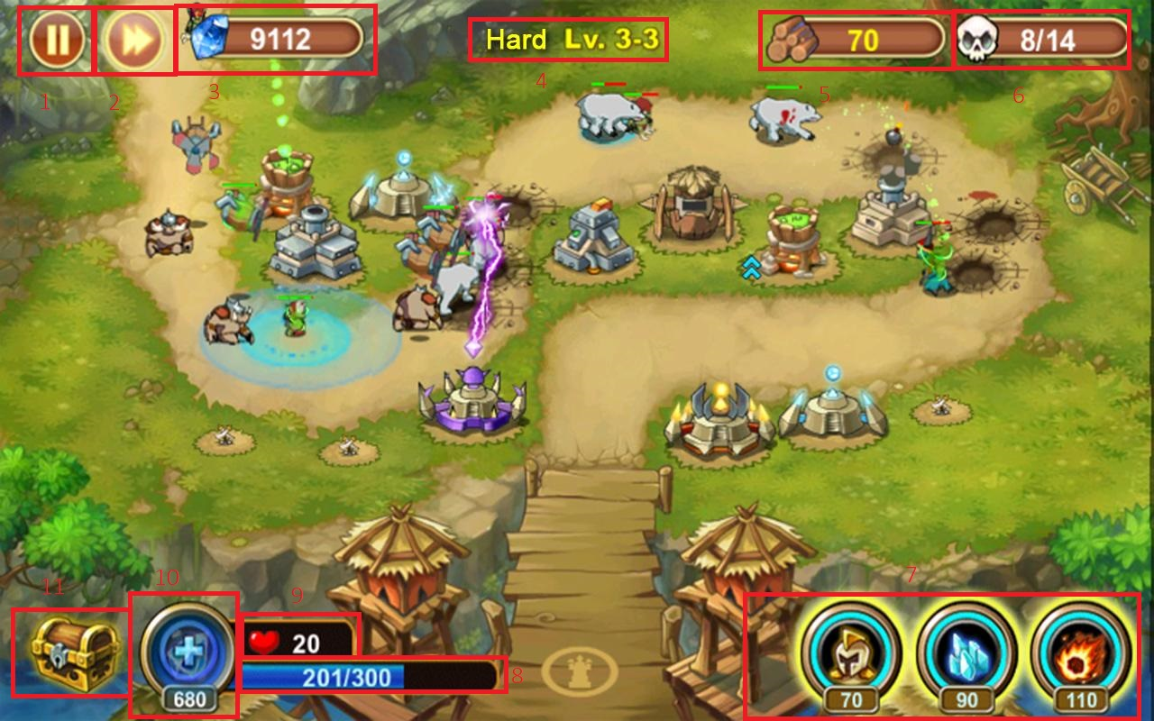
Screenshot from https://www.appgamer.com/castle-defense/

Elements
1 - Settings
2 - Speed Settings
3 - Reward Resources
4 - Current Map Name
5 - Current Building Resources
6 - Current Wave Count
7 - Abilities List
8 - Abilities Resources
9 - Current Lives Left
10 - Option to Convert Reward Resources to Abilities Resources
11 - Purchase Permanent Upgrades with Reward Resources

20. South Park Let’s Go Tower Defense Play!
Played on Xbox 360.
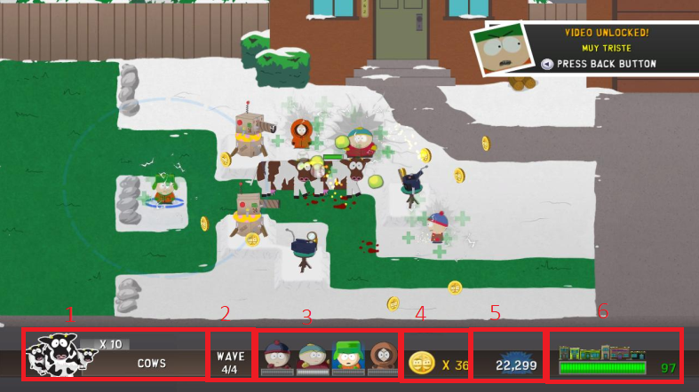
Screenshot from http://www.pixlbit.com/review/24/south_park_lets_go_tower_defense_play_review

Elements
1 - Current Wave Information
2 - Current Wave Count
3 - Abilities List
4 - Current Building Resources
5 - Current Score
6 - Current Lives Left

